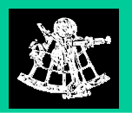Inspection Defect Log

 |  | Meeting Date: | 8/27/01
Project: | Client Order Entry Daemon | Release: | 8/22/01
Activity: | Inspection of Detail Design Document | Document: | XCOES Daemon design
Component: | GUTS and PL/1 design and flow functions | Moderator: | Cynthia Killian

Location  (Page-Section-Line) | Defect Description | Type | Class | Severity
9:15
1-1-A | XCOES table is misleading. What is it? How is it used? | DC | W | N
1-3-A | Explain FIELD to clarify meaning | DC | W | N
1-5-B | Traceability missing between Detailed Design & Task Summary | DC | W | N
1-8-A | Incorrect description of HOW daemon processes entries | DC | W | N
1-(1-8) | Did not discuss SUSPEND/RESUME function | DC | M | N
1-(1-8) | Did not mention that this applies to JST or COES | DC | M | N
9:30
2-12-A | What code is eliminated from XCOES.Logon ? | DC | M | J
2-12-E | How will logic work ? Switching over to any GUTS environment (Prod to Test). | FN | M | N
2-16-F | Missing Name for the OS file | DC | M | J
2-16-N | Does not explain how SUSPEND/RESTART options is limited | FN | M | J
2-16-K | Do we need to SUSPEND individual daemons ? Missing traceability back to Requirements | DC, RQ | M | N
2-16 | Missing Traceability for environment variables setup between Task Summary and Module Flows | DC | M | N
9:45
3-22-L | Explain functionality for setting priority to Low | DC | M | N
3-22-J | No traceability between FUA checking to module flows | DC | M | N
3-22-J | Requeued where ? What will be requeued ? | DC | M | N
3-22-(N-S) | Statements should be moved to the beginning of Section/Paragraph | FN | W | J
3-22-N | How will MAXSUBS be populated and adjusted ? | DC | M | N
4-2-8 | Who are the users ? Need to be added to SOPs | DC | M | N
10-A | Missing functionality – How to switch to Test daemon | FN | M | J
11-3 | What OS file (Box 3) | DC | M | N
12 | Missing step (userid for COES sub) Where is this created ? | FN | M | J
12-2 | Add “FOR UPDATE” to pseudocode in Box 2 | DC | M | N
10:00
13 | Box (2-3) need more detail | FN | M | N
15-4 | When do you write this line out ? | FN | M | N
1 | Missing As-Is, To-Be from Functional Requirements | RQ, DC | M | N
1 | Missing traceability between Requirements & Detail design (business process flow to functional flows). | RQ | M | J
1 | Where is success criteria ? | RQ | M | J
10:15
1-7 | How do we adjust sleep time for daemons ? | DC | M | N
1-1 | What GUT(x) environments will this work in ? Is there any impact to the design if ITO moves GUT(x) environments to different LPARs (assumed None) ? | DC | M | N
REQ | Are there any reports providing summarized metrics of XCOES performance to ensure we meet the throughput needs for the clients (“success criteria” ) ? | RQ | M | J
REQ | Do we (need to) capture the audit trail of SUSPEND & RESUME commands and who entered them ? | RQ | M | N
Design Detail | Are there any concerns with always capturing the XCOES ID as the User ID in the XCOES table ? | FN | M | N
All Flows | General issue: Where is the Error Handling logic throughout all the processing ? | FN | M | J
10:30

Defect Summary:

32 Total Defects

10 Major Defects { 7 w/in the Team (Inside), 3 Outside our control}

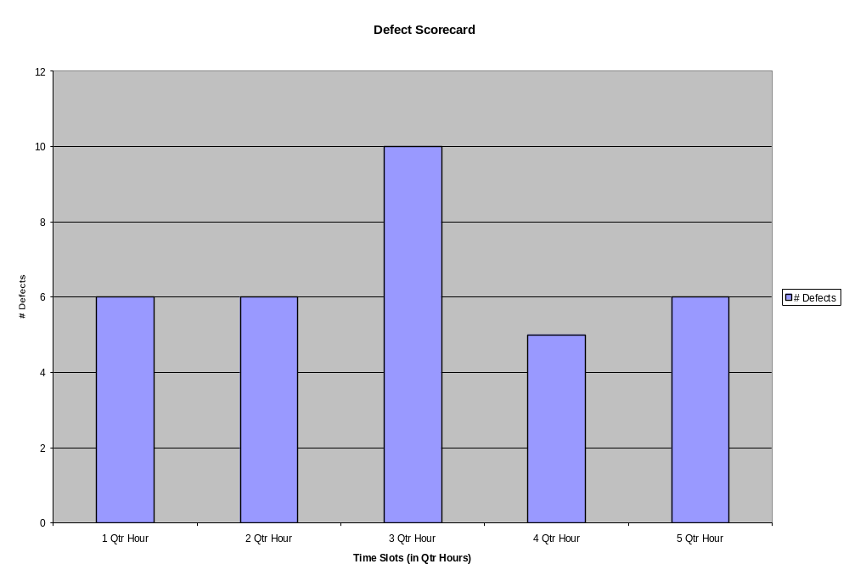

ROI Summary:
Assumption: $1500/Major Defect
Assumption: $70/FTE (Hourly Rate)

Preparation Time:
Jeff 1.25 Hrs
Cynthia 2.50 Hrs
Susan 1.00 Hrs
Tom 0.50 Hrs
Sam 1.00 Hrs
Total 6.25 Hrs

Inspection Execution Time:
5 FTEs x 1.5 Hrs = 6.25 Hrs

Total Cost for Inspection: 12.5 Hrs x $70/Hr = $875
Total Potential Costs Saved from preventing 10 Major Defects: 10 Major Defects x $1500/Major Defect = $15,000.

ROI = $15,000 - $875 = $14,125

Defect Type:
DA—data | DC—documentation | FN—functionality | HF—human factors | IF—interface
IO—input/output | LO—logic | MN—maintainability | OT—other | PF—performance
SN—syntax | ST—standards | TC—test case | TE—test environment | TP—test plan
PP—Project Plan | PS—Project Scope | RQ—Requirements | QA—Quality Plan

Defect Class: M—Missing:
M-Missing | W-Wrong | E-Extra

Defect Severity:
J—Major | N-Minor

